A Mini Project Report on

**ENGINEERING MECHANICS**

*Submitted in partial fulfilment of the requirement for the Degree of*

**B. Tech.**

in

**Computer Science and Technology**

*Submitted By:*

**Members of Group 22, CSE ‘K’**

**Prottay Kumar Adhikary : 1912157**

**Saurabh Sinha : 1912159**

**Subhojit Ghimire : 1912160**

*Under the guidance of:*

**Dr. Simanchal Kar**

**Assistant Professor**

**Department of Mechanical Engineering**

**NIT Silchar**

**NATIONAL INSTITUTE OF TECHNOLOGY SILCHAR**

**END-SEMESTER MINI PROJECT (B. TECH.) JULY-2020**

**SECOND SEMESTER (SECTIONS: F, G, H, I, J, K)**

**COURSE. ME 101 SUB.: ENGINEERING MECHANICS**

**TIME: 3 HOURS MAXIMUM MARKS: 100**

*Answer all questions.*

*Figures in the right hand margin indicate marks.*

**Group I [20 Marks]**

**1. Fill in the blanks:**  *[1×10=10]*

**i)** A __________ is defined as a two-dimensional framework of straight prismatic members connected at their ends by frictionless hinged joints, and subjected to loads and reactions that act only at the joints and lie in the plane of the structure. [Plane Truss]

**ii)** __________ is the study of the relations between unbalanced forces and the resulting changes in motion. [Kinetics of Particles]

**iii)** A wedge converts a force applied to its blunt end forces __________ to its inclined surfaces. [Wedge Friction]

**iv)** The theorem of Pappus and Guldinus is used to find the __________. [Theorem of Pappus-Guldin]

**v)** Plane motion of a rigid body takes place if every point in the body remains at a __________ distance from a fixed plane. [Statics of Rigid Body]

**vi)** __________ is the simplest type of motion and is along a straight line path. [Kinetics of Particles]

**vii)** According to the principle of conservation of energy, under the action of __________ force, the sum of P.E and K.E of a particle remains constant. [Principle of Work and Energy]

**viii)** Angular momentum is proportional to __________ and __________. [Principle of Impulse and Momentum]

**ix)** __________ is an equation relating the magnitudes of three coplanar, concurrent and non-collinear vectors, which keeps an object in static equilibrium with the angles directly opposite to the corresponding vectors. [Static Equilibrium]

**x)** The theorem states that the torque of a resultant of two concurrent forces about any point is equal to the algebraic sum of the torques of its components about the same point is called __________. [Varignon’s Theorem]

*[Turn Over]*

**2. True or False:**  *[1×10=10]*

**i)** The screw-jack works on the same principle on which an inclined plane works. [Simple Screw Jack]

**ii)** The frictional force in Belt Friction decreases with the amount of wrap about a surface and makes it so the tension in the belt can be different at both ends of the belt. [Belt Friction]

**iii)** A simply supported beam is one whose one end is fixed and the other end carries a point or concentrated load. [Beams- Types of Loads]

**iv)** Couple, in mechanics, is pair of equal parallel forces moving in same direction. [Couple]

**v)** The moment of inertia is a physical quantity which describes how easily a body can be rotated about a given axis. [Moment of Inertia]

**vi)** Impact occurs when two bodies collide during a very short time period, causing large impulsive forces to be exerted between the bodies. [Direct and Oblique Collision]

**vii)** According to work energy principle, a particle of mass m when subjected to unbalanced force system, the work done during displacement by all forces is equal to change in potential energy during displacement. [Principle of Work and Energy]

**viii)** Moment of Inertia is the integration of the square of the distance of the centroid and the del area along the whole area of the structure. [Kinetics of Rotation Motion]

**ix)** The parallel axis theorem can add any angle varied moment of inertias to give the perpendicular moment of inertia. [Moment of inertia]

**x)** Radius of Gyration is the perpendicular distance from the point mass to the axis of rotation. [Parallel and Perpendicular Axes Theorem]

*[Turn Over]*

**Group II [20 Marks]**

**3. Multiple Choice Questions:** *[2x10=20]*

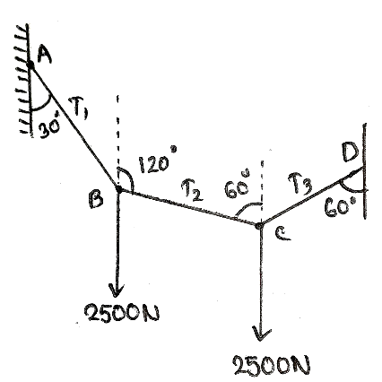**i)** Two equal loads of 2500N are supported by a flexible string ABCD at points B and C. Find the tensions in the portion AB, BC and CD of the string. [Statics of Rigid Body]

**a.** T1=2500N, T2=4330N, T3=2500N

**b.** T1=4330N, T2=2500N, T3=4330N

**c.** T1=4330N, T2=2500N, T3=2500N

**d.** T1=2500N, T2=2500N, T3=4330N

**ii)** Determine the forces exerted on the cylinder at points A and B by spanner wrench due to the vertical force of 200N applied to the handle. Neglect friction at B. Draw the free body diagram for cylinder and wrench separately. [Moment of Force]

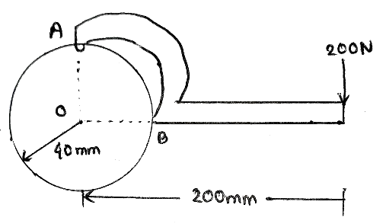

1. 1000N, 1010N
2. 1020N, 1000N
3. 1000N, 1030N
4. 1040N, 1000N

**iii)** Find F and α for the given figure. [Lami’s Theorem]

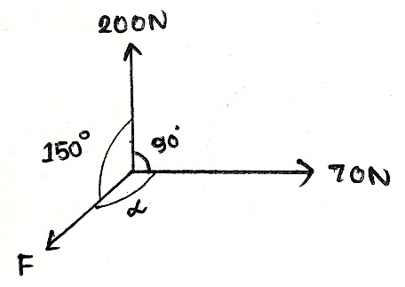

1. F=160N, α=120⁰
2. F=150N, α=120⁰
3. F=140N, α=120⁰
4. F=130N, α=110⁰

**iv)** The ratio of tension of two sides of a flat belt is given by _________. [Belt Friction]

1. e-µθ **b.** e µθ
2. **c.** e x µ x θ **d. $\frac{e^{θ}}{μ}$**

*[Turn Over]*

**v)** A truss consisting of 8 joints, 10 members and 4 reaction components is called: [Plane Truss]

**a.** Cantilever truss **b.** Deficient truss

**c.** Redundant truss **d.** None of the above

**vi)** A man can swim in still water at a speed of 3 km/h. He wants to cross a river that flows at 2 km/h and reach the point directly opposite to his starting point. How much time will it take for him to cross the river if the river is 500 m wide? [Kinematics of Particles]

1. $\frac{1}{3\sqrt{3}}h$**b. $\frac{7}{2\sqrt{5}}h$**

**c. $\frac{2}{3\sqrt{2}}h$**  **d. $\frac{1}{2\sqrt{5}}h$**

**vii)** What is the minimum velocity attained by a ball thrown with velocity of 20 m/s at an angle of 40⁰ with the horizontal? [Projectile Motion]

1. 15.32 m/s **b.** 12.85 m/s

**c.** 16.78 m/s **d.** 11.32 m/s

**viii)** When a particle moves with a uniform velocity along a circular path, then the particle has: [Kinetics of Rotational Motion]

1. Tangential acceleration only
2. Centripetal acceleration only
3. Both tangential and centripetal acceleration
4. None of the mentioned

**ix)** A train covers 60 miles between 2 p.m. and 4 p.m. How fast was it going at 3 p.m.? [Kinematics of Plane Motion]

1. 60 mph **b.** 30 mph

**c.** 40 mph **d.** 50 mph

**x)** A heavy object and a light object have the same momentum. Which has the greater velocity? [Principle of Impulse and Momentum]

1. Heavy object **b.** Light object
2. Both have the same velocity **d.** None of the mentioned

*[Turn Over]*

**Group III [60 Marks]**

**4. Numerical type problems:** *[6 x 10 = 60]*

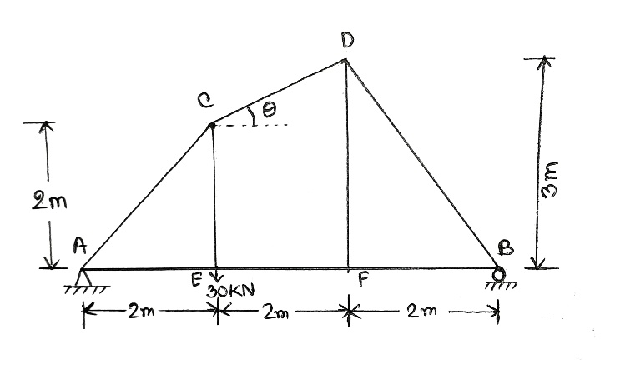**i)** A plane truss is supported and loaded as shown in the figure. Find the axial force in members CD, EF and CF by the method of sections. [Plane Truss- Method of Sections]

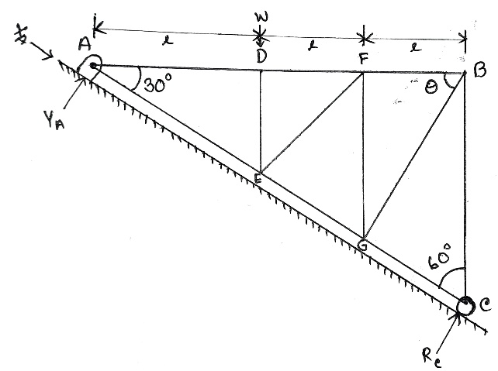**ii)** Find the axial forces in the members BC, BG, BF, GC, GF and GE of the truss supported and loaded in the given figure using the method of joints. [Plane Truss- Method of Joints]

**iii)** Four equally heavy uniform rods are freely joined to form a rhombus which is freely suspended by one angular point B and the middle points of the two upper rods are connected by a light rod so that the rhombus cannot collapse. Find the tension of this light rod. [Virtual Work]

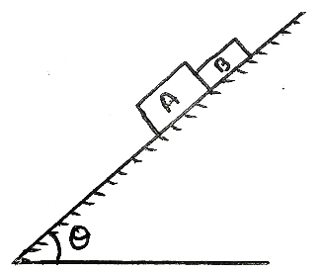**iv)** Two blocks A and B of weights 250N and 150N rest on a plane which is slowly raised from the horizontal position to an angle θ. Find the maximum angle that can be reached before bodies slip down the incline. Assume the coefficient of friction between the block B and the plane is 0.2 and the coefficient of friction between the block A and the plane is 0.3. [Friction]

*[Turn Over]*

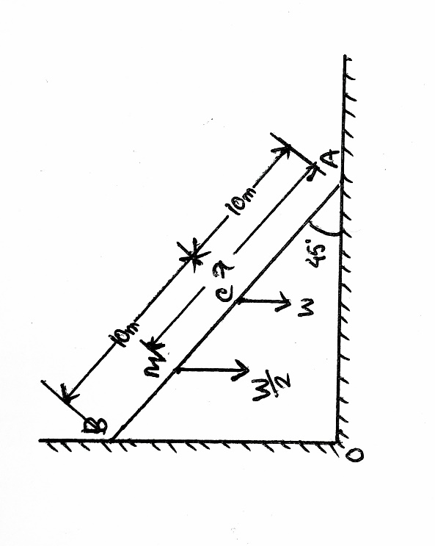**v)** A uniform ladder AB of length l=20m and weight W is supported by the horizontal floor at A and y a vertical wall at B. It makes an angle 45⁰ with the horizontal. If a man, whose weight is one-half that of the ladder, he shall climb before the ladder slips. [Ladder Friction]

**vi)** A projectile is launched from a cliff 100 m above the ground level with a lunch velocity of 30 m/s and a launch angle of 20⁰ above the horizontal. Determine the projectile’s **(a)** range, and **(b)** peak height. [Projectile Motion]

**vii)** A 4kg ball moving west at a speed of 5m/s strikes a 2kg ball at rest. Calculate the velocities of the two balls assuming a perfectly elastic collision. Also check the validity of the answer with the conditions for elastic collision. [Direct and Oblique Collision]

**viii)** For a projectile motion, derive the equations of **(a)** time of flight, **(b)** maximum vertical distance covered, and **(c)** maximum horizontal distance covered. [Projectile Motion]

**ix)** An 8kg mass is placed on a 30⁰ frictionless inclined plane and is attached to a pulley connected to a hanging mass of 5kg. Find **(a)** the acceleration, **(b)** tension in the rope, and **(c)** the hanging mass that will cause system to remain at rest. [Kinetics of Particles]

**x)** Two cars namely P and Q are travelling in parallel lanes on a straight highway with a uniform velocity of 60 km/h. Car P is ahead of car Q by 250m. At a certain instant, car P decelerates uniformly at 2.5 m/s2, whereas car Q accelerates uniformly at 2 m/s2. Will the car Q overtake car P? If yes, when and where will the car Q overtake car P? [Kinematics of Plane Motion]